# **Part 2: Project Scope Management**

Managers at Manage Your Health, Inc. (MYH) selected Tony Prince as the project manager for the Recreation and Wellness Intranet Project. The schedule goal is **six months,** and the **budget is $200,000.** Tony has previous project management and systems analysis experience within the company, and he is an avid sports enthusiast. Tony was starting to put the project team together. He knew he would have to develop a survey to solicit input from all employees about the new system and make sure it was user-friendly.

Recall that this system would include the following capabilities:

* Allow employees to register for company-sponsored recreational programs, such as soccer, softball, bowling, jogging, and walking.
* Allow employees to register for company-sponsored classes and programs to help them manage their weight, reduce stress, stop smoking, and manage other health-related issues.
* Track data on employee involvement in these recreational and health-management programs.
* Offer incentives for people to join the programs and do well in them (e.g., incentives for achieving weight goals, winning sports team competitions, etc.).

Assume that MYH would not need to purchase any additional hardware or software for the project.

**Tasks**

1. Develop a **first version of a project scope statement** for the project. Use the template provided on the companion Web site for this text and the example in Chapter 3 as guides. Be as specific as possible in describing **product characteristics and requirements**, as well as all of **the project’s deliverables**. Be sure to include testing and training as part of the project scope.

Scope Statement (Version xx)

|  |
| --- |
| **Project Title: Recreation and Wellness Intranet Project**  **Date:** Feb. 10 **Prepared by:** Tony Prince, Project Manager, (84)555-5896 |
| **Project Justification:** Senior management at MYH, Inc. suggested this project to help improve employee health and reduce health care premiums, which are 20 percent above the industry average. Estimated savings are $30/employee per year for four years. |
| **Product Characteristics and Requirements:**   1. The new system must run on the existing intranet using current hardware and software as much as possible 2. The new system must be very user-friendly 3. The main requirements of the system are to  * Allow employees to register for company-sponsored recreational programs, such as soccer, softball, bowling, jogging, and walking * Allow employees to register for company-sponsored classes and programs to healp them mange their weight, reduce stress, stop smoking and mange other health-related issues. * Track data on employee imvolvement in these recreational and healthy-management programs * Offer incentives for people to join the programs and do well in them (i.e. incentives for achieving weight goals, winning sports team competitions, etc.) |
| **Product User Acceptance Criteria:**  **Summary of Project Deliverables**  **Project management-related deliverables:** business case, charter, team contract, scope statement, WBS, schedule, cost baseline, status reports, final project presentation, final project report, lessons-learned report, and any other documents required to manage the project.  **Product-related deliverables:** research reports, design documents, software code, hardware, etc.   1. Requirement definition: Define the requirements for the new system. Includes developing and administering a survey to current employees to help to determine desired programs, courses, incentives and content and features for the new system. 2. Web site design: An intitial design of the new intranet site will include a site map, suggested formats, appropriate graphics, and design of the required features like registration, tracking, etc. The final design will incorporate comments for users on the intitial design. 3. Web site development: The intranet site will include content for the programs, classes, and incentives as well as features for registration, tracking, and incentives management. 4. Testing: Testing will include the development of test plans to document how the system will be tested, who will do the testing, and how bugs will be reported 5. Training: Training will be provided for the new system, both on-line and in-class 6. Roll out and support: There will be a well-defined plan for rolling out the new system, supporting users, and providing updates, enhancements, or other support, as required |
| **Project criteria success:** Our goal is to complete this project within six months for no more than $200,000. The main goal is improve employee health to negotiate lower insurance premiums. Even having this program should help us negotiate lower premiums, and tracking improvements in employee health will provide solid evidence for lower premiums and have other benefits, like improved morale and productivity. |

1. Develop a work breakdown structure for the project. Break down the work to Level 3 or Level 4, as appropriate. Use the template on the companion Web site and samples in this text as guides. Print the WBS in list form. Be sure the WBS is based on the project charter earlier, the project scope statement created in Task 1, and other relevant information.
2. **Project Management**
3. **Requirements Definition**
4. **Web Site Design**
   1. Registration for recreational programs
   2. Registration for classes and programs
   3. Tracking system
   4. Incentive system
5. **Web Site Development**
   1. Registration for recreational programs
   2. Registration for classes and programs
   3. Tracking system
   4. Incentive system
6. **Testing**
7. **Training, Roll out, and Support**

**Homework:**

1. Use the WBS you developed in Task 2 to begin creating a Gantt chart using your choice of software. Do not enter any durations or dependencies. Print the resulting Gantt chart on one page, and be sure to display the entire Task Name column.

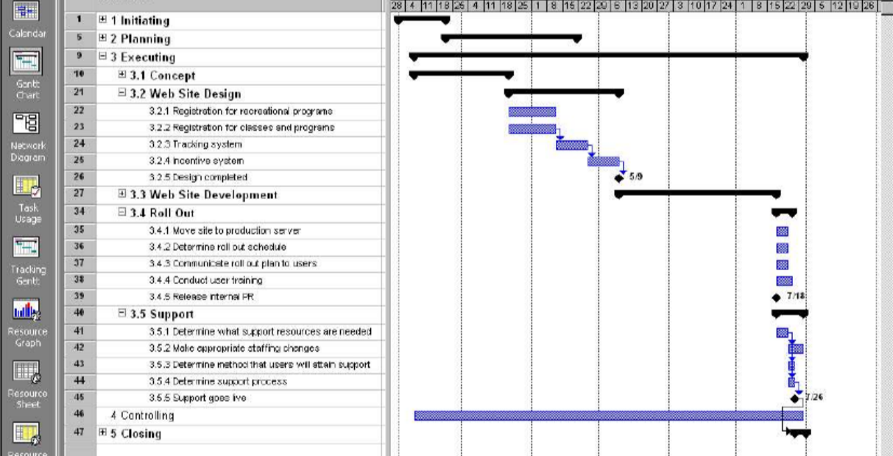

1. Develop a strategy for scope validation and change control for this project. Write a short paper summarizing key points of the strategy.

Document your approach for collecting requirements for the project. Include at least five technical requirements and five non-technical requirements in a requirements traceability matrix. Also develop a list of at least five questions you would like to ask the project sponsor. Let your instructor answer them for you, if applicable.

How long should the events last?

What activities will we need to provide for attendees?

Should we use local beverages or international beverages?

What is our procedure for any last-minute cancelations?

How should we handle fraud attempts?

Develop a strategy for scope validation and change control for this project. Write a short paper summarizing key points of the strategy.

At the end of each event an event summary will be produced by the assigned host. We will also gather customer and participant feedback if possible. The company will then determine the overall successfulness of the event. This will be done for all events in a three-month time frame, and the results will be gathered and documented before presenting the results to the sponsor. The company site will contain a private feedback page. On this page an employee can request any changes they would like to see in the company, voice any concerns with upcoming events or staff, voice any concerns with investors or event planners. This page will also be used to formally announce resignation or request a leave. The page will automatically send and email to the project director when a request is submitted.